Wix Design Fundamentals

Designing on Wix is based on a drag and drop approach. To design any site we need to know about all the Wix Elements in depth, So that before designing a site we must have knowledge about Wix elements to make our design smooth, full and fast.

Let's go in detail about how to design wix sites in the proper way.

As We know that there are three methods of Wix website design.
- WIX ADI ( Artificial Design Intelligence )
- WIX EDITOR
- Editor X

ADI (For fresh build it’s preferable to use Wix Editor method)

An Artificial Intelligence Wix Design method

Let's Start with First Wix ADI:

How to design site using Wix ADI by best Practice and Standardize

Intro: Answer a few simple questions and automatically get a website designed. It’s ready made web templates by wix, based on our requirement

To design the site just follow the Steps below:

Step 1:
Sign In / Sign Up in Wix.com

Step 2:
Either click on the skip button or click on let's DO it
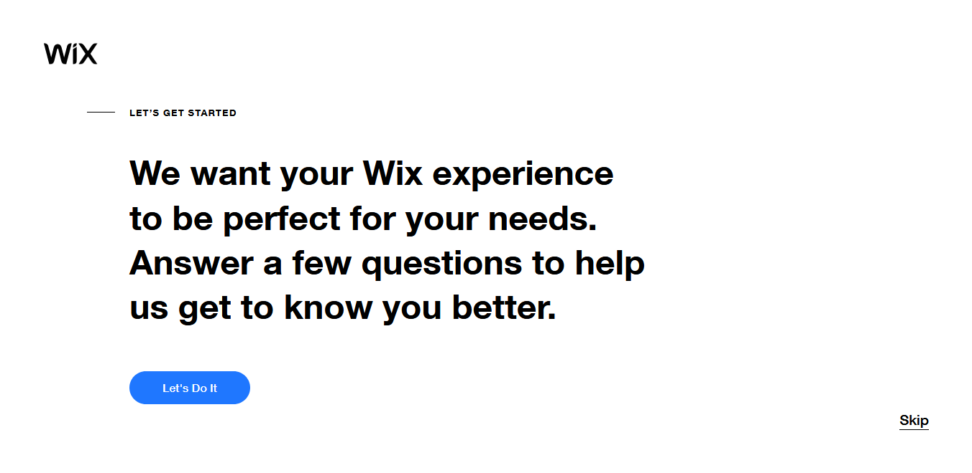
If you go with let's do it button This is Wix ADI method, so We need to answer a few questions regarding site information.

Better we follow with Skip button
After click on the skip button Wix, you will ask to choose “ How you want to Create Your Website ”
- Using ADI
- Wix Editor
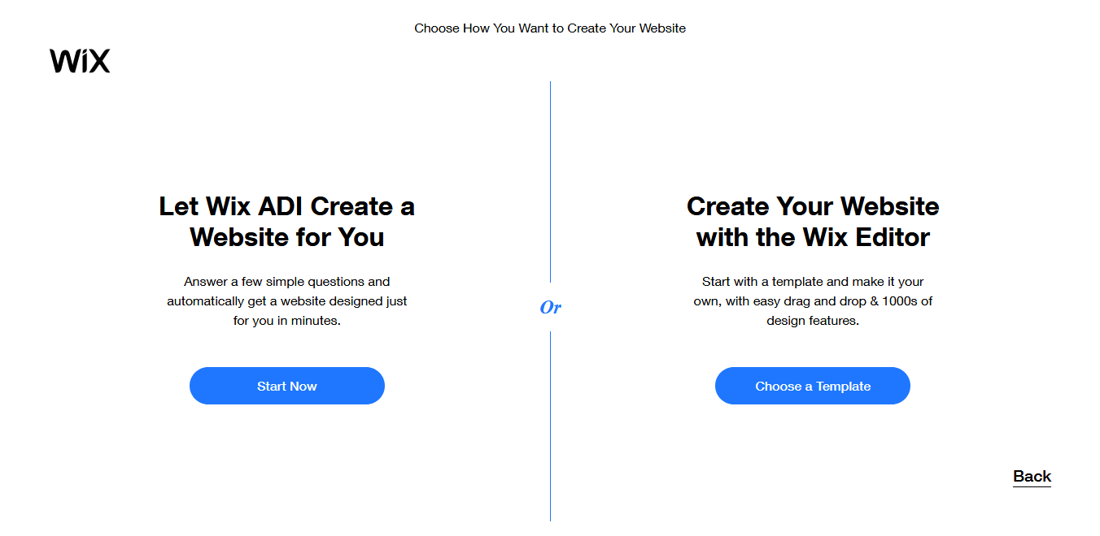

Step 3:
- Choose Wix ADI Click on “Start Now” Button
- Select the type of site you want to create then Click on Next
- Select or deselect selected Recommended Wix Apps then Click on Next
- Enter Name of your Website
- Ask to import content Skip this step
- Review and Edit your info
- Pick a theme you like

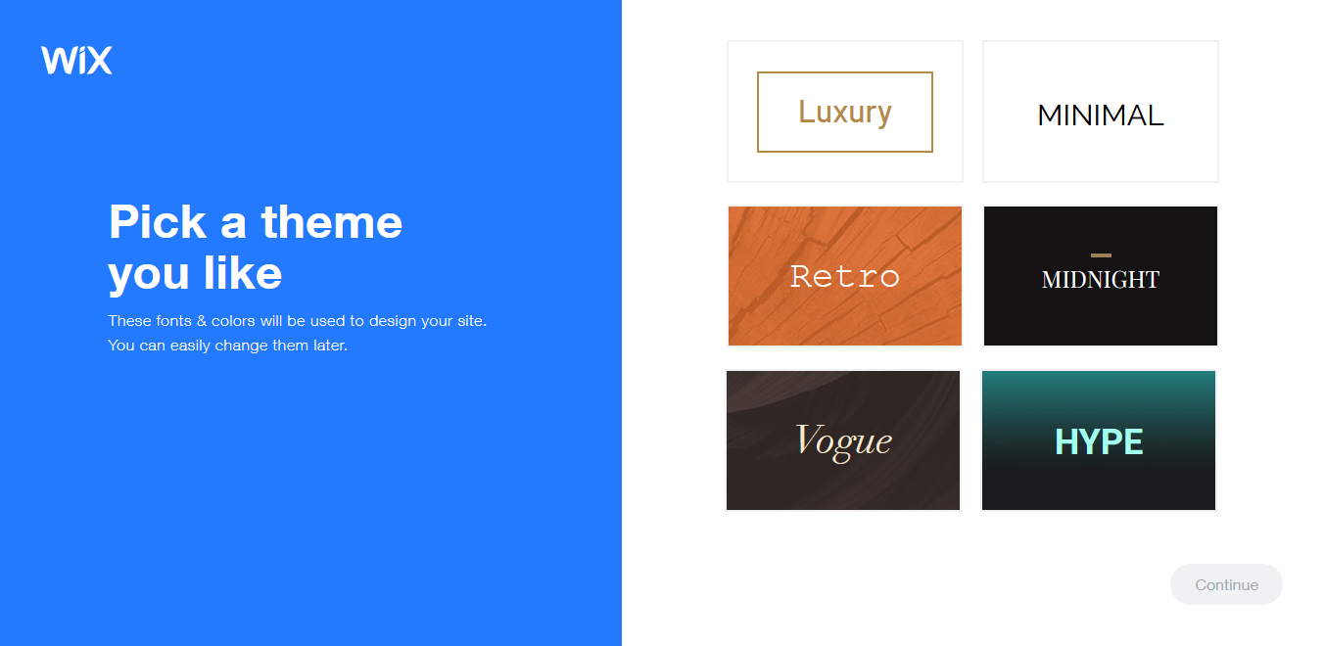
- Select any theme and Continue
- Pick your favorite Homepage Design or you can also skip this steps then Next
- Your site is ready, now you need to Publish the site or Preview
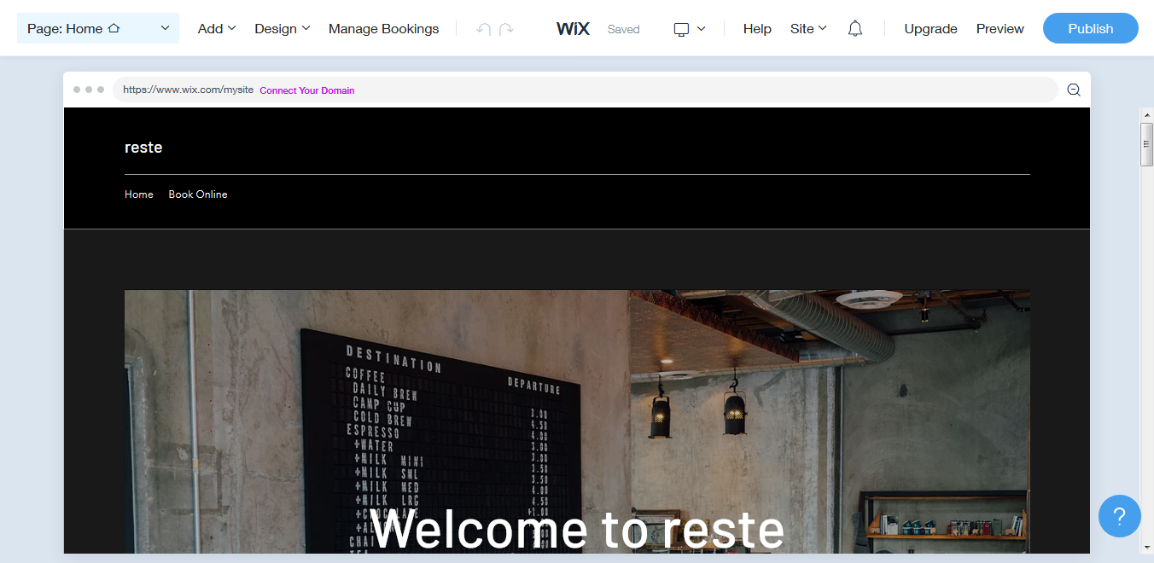

Wix Editor (This method allow us creating complex custom sites)

To design the site just follow the Steps below:

Step 1:
Sign In / Sign Up in Wix.com

Step 2:
- Choose Your Website with Wix Editor

If you already on the page my account then click on the Create New Site

Step 3:

- When You click Create New Site, it will ask you to choose the category of your website which you want to create.
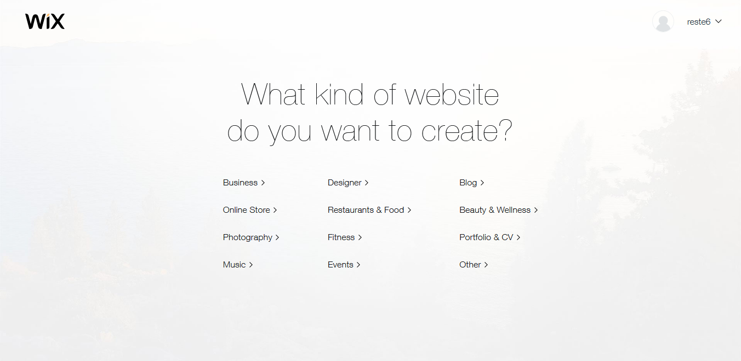

Step 4:

After Select of Category it will ask again to choose how you want to create your website
- ADI
- Wix Editor
Choose Wix Editor and click on Choose a Template Button

Step 5:
You will land on template listing page

Here is the two way to create website using Wix
- Select Template which is suitable for your website and Click on Edit Button
- Click on Blank Templates Link on the Left Sidebar and create your website from scratch using Blank Template.

By Wix Ready Template Method:

Let’s Go with First Method by Selecting Wix Template
( Wix Provide approx thousands of ready made Templates based on different Categories. )

Step 1:

Choose any Template and Click on Edit Button
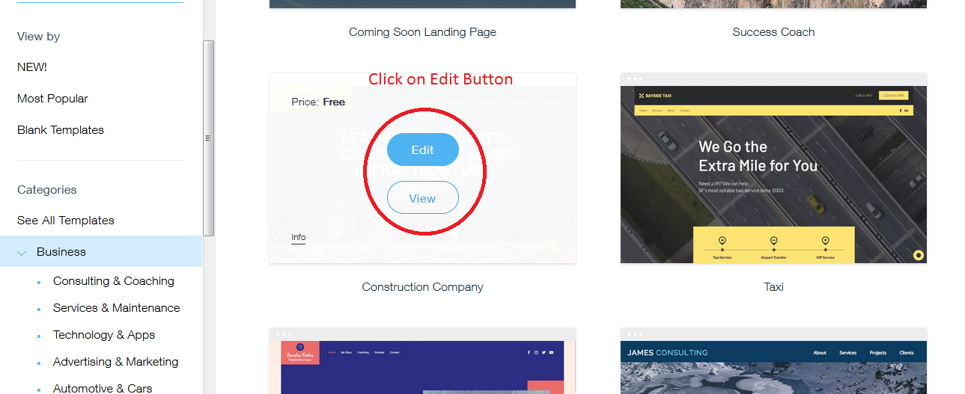

Step 2:

Your Site is ready to Publish
You need to change the text and images according to your site and then Publish your site.

NOTE: We always approach a blank template for designing a website from scratch, Wix provided template is not recommended.

By Start from Scratch:

Second method: Click on Blank Templates Link on the left Sidebar and create your website from scratch using Blank Template.
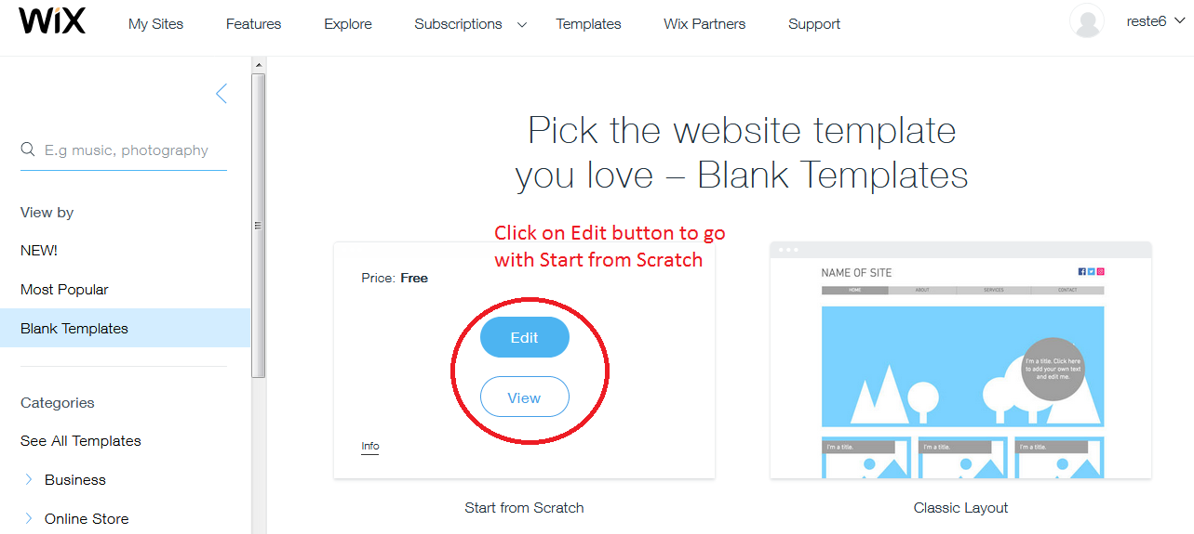

Step 1:
After you click on the edit button, you will go to the wix website builder page where you can find all the Wix Elements to add on the page. You will find a complete Blank Page , Blank header and blank Footer, you need to design according to your requirement as you want.
First Top Section is Header and Center Part is the Content of the page part and last one is footer part.

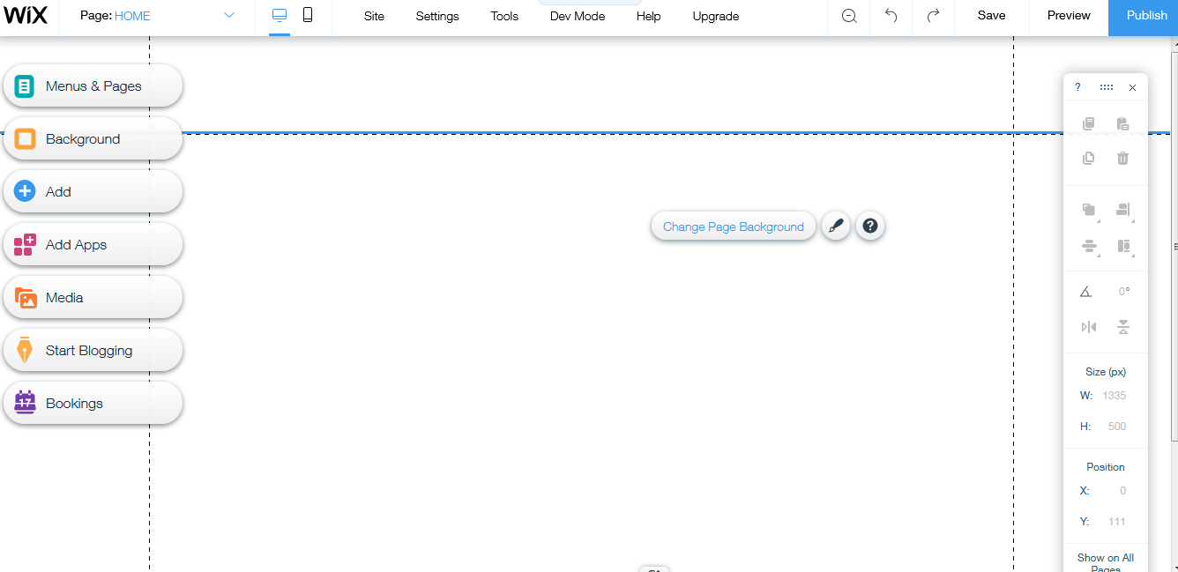

Standard Way to Design Wix Website

Following steps to be taken to design the site in a Complete way.

Step 1:
Strip Wise design

Step 2:
Native Wix App or Third Party App as needed

Step 3:
Add Wix Ascent ( Form & Chat )

Step 4:
Complete SEO Wiz

Step 5:
Publish The Site

Step 6:
Connect with Live Domain

Let Us Explain in depth of all these steps one by one

Strip Wise design

What is STRIP:

Strip is just similar to section , so to design a site like to add about us section on the page so to do this first you need to add blank strips and then you can add elements to create design.
All the design of the site should be stripwise.

Note: All the elements must be attached with a strip, if not attached then that element will be mismatched from their position in Mobile Layout.

Please follow the Steps to design the Strip.

Step 1:
Click on ADD ( + ) Sign on the left hand of tools list

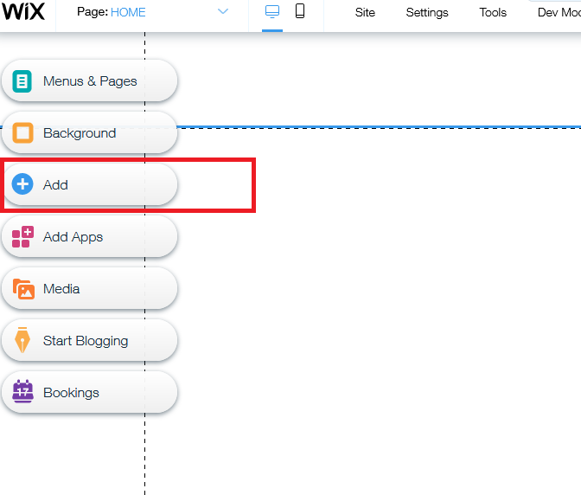

Step 2:
Click on Strip then hover over Classic Section

Step 3:
Select ether black background strip or White Strip

Step 4:
Drag the strip and drop on the content area of the page.
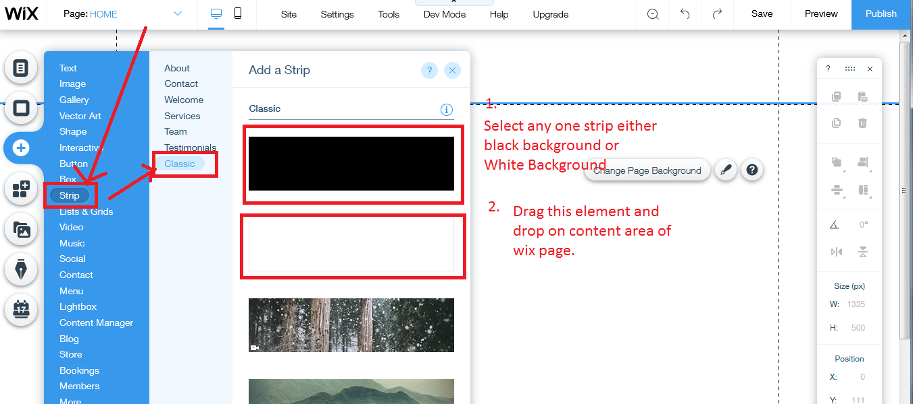

Step 5:
Adjust the height of the strip according to the sections from the original website.

Step 6:
Change the strip background as required.
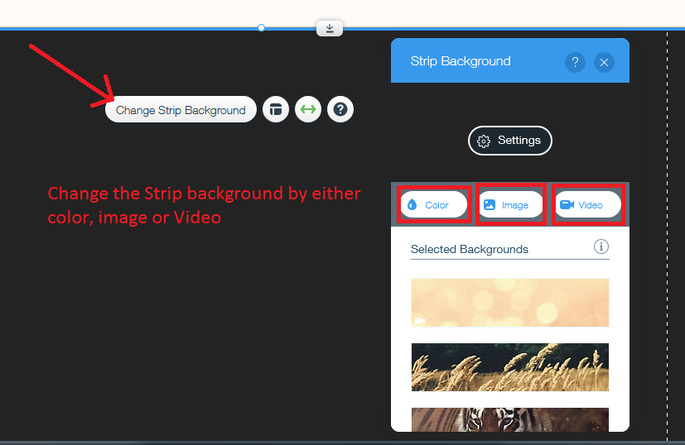

Step 7:
Click on the layout button add more column on the page
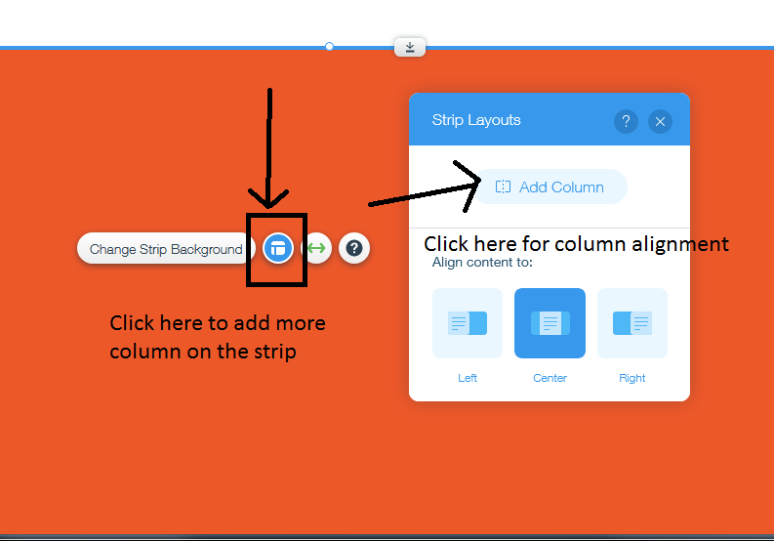

Step 8:
Change the column background by image using three Free resources on Wix Media center
- Wix Media
- Shutterlock
- Unsplash
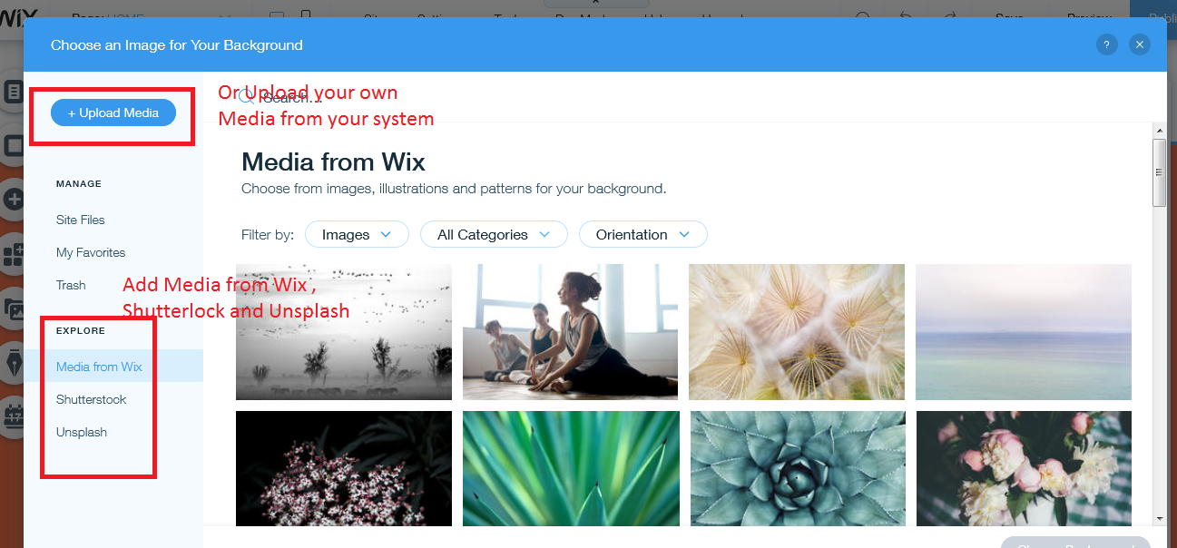

Step 9:
Go to the Text Element Select Themed text , Titles, or Paragraphs
Add Heading or text on the page and Click on Edit Text and change the fonts formats as you want and at last click on save theme

Note: save theme will give you option to set the font format globally

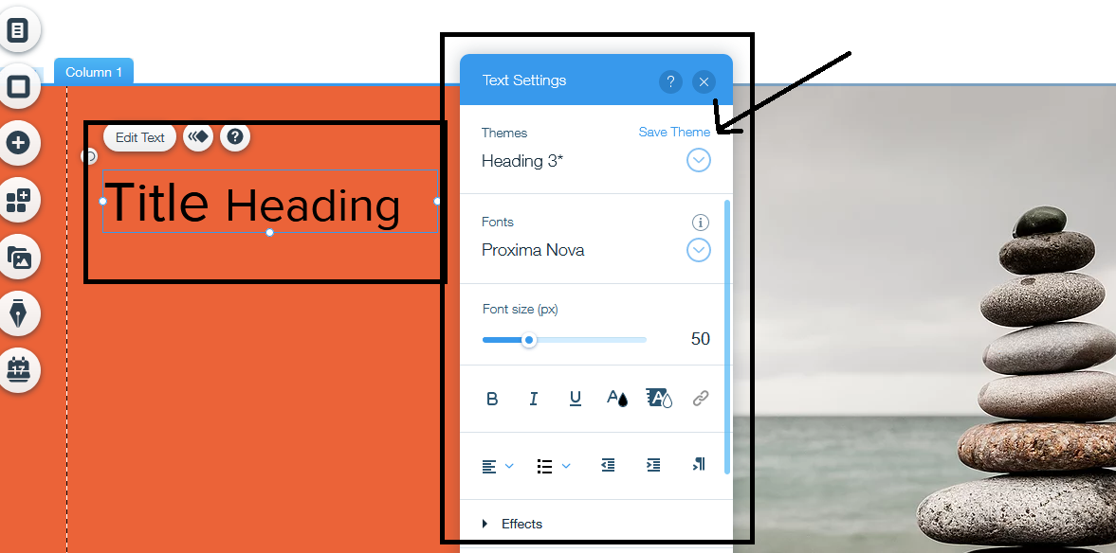

Step 10:
Add Paragraph and button the column and now basic strip is completed


Note : Wix have provided many featured Elements to design the site.
Some Elements are as follows:
- Text
- Image
- Gallery
- Vector Art
- Shape
- Strip
- Lists & Grid ( Repeater )
- Video
- Music
- Social
- Lightbox
- Database
- Blog
- Store
And some more

Toolbar

Toolbar is used to check the height & Width of strips and elements of wix during design
Toolbar provide following tools for design
- Content Alignment ( left, right, & center )
- Elements Width & height
- Elements position by X & Y axis
- Copy Element
- Duplicate button
- Move element Front and behind each other
- Rotation by degree
- Flip
- Layer button to check all the strip layer on the page.
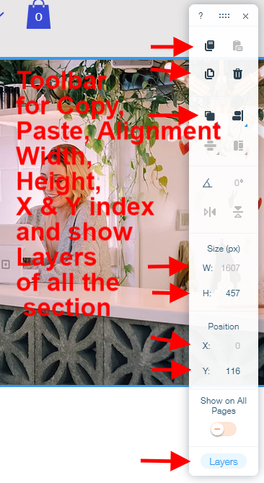

Layer

All the design in wix is layered based. If you create one strip then it will come on layer.
So in last you can check all the layers of elements used during the design of the page and you can also move the layer up & down according to your need.

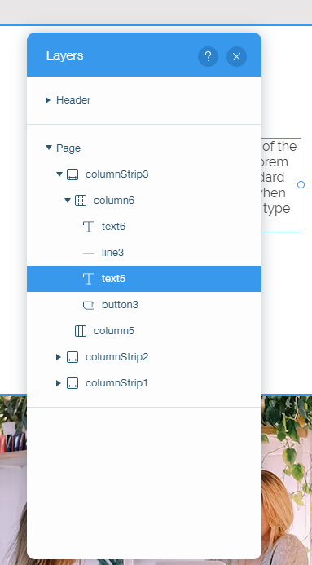

Native Wix App or Third Party App as needed

What is App:

Into :
Wix App is an add-on of functionality to add some functionality on wix site as per requirement.

Suppose if you want to add online store Functionality on the wix site, you need to add the Wix Store App from Wix App Center.

Similarly Some are Wix provided App and Some are Third party App which has been developed by a third party and posted on Wix App center. You can use any app as you want but keep in mind that some App is free and some are premium, So before using App you need to check the free or premium version with your own.

Add App:
Just Click on Add App button and then after so the setting as required and add the element on the wix page to show on the front-end.

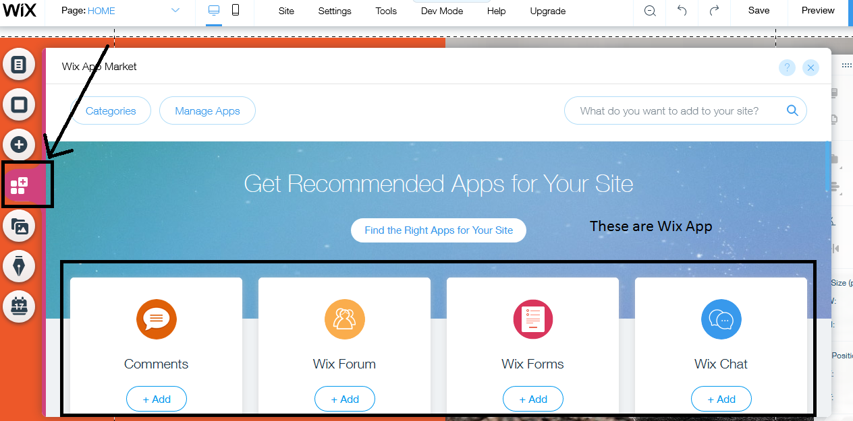

Ascent

What is Ascent:
Ascent connects with your customers, automates your work and grows your business with Ascend by Wix. Introducing your all-in-one business solution, chosen by millions of business owners worldwide.

Ascent includes following forms and functionality which are Connect and Management Ascent

- Chat
- Forms
- Inbox
- Automation
- Members
- Invoice
- Workflows
- Task & Reminders

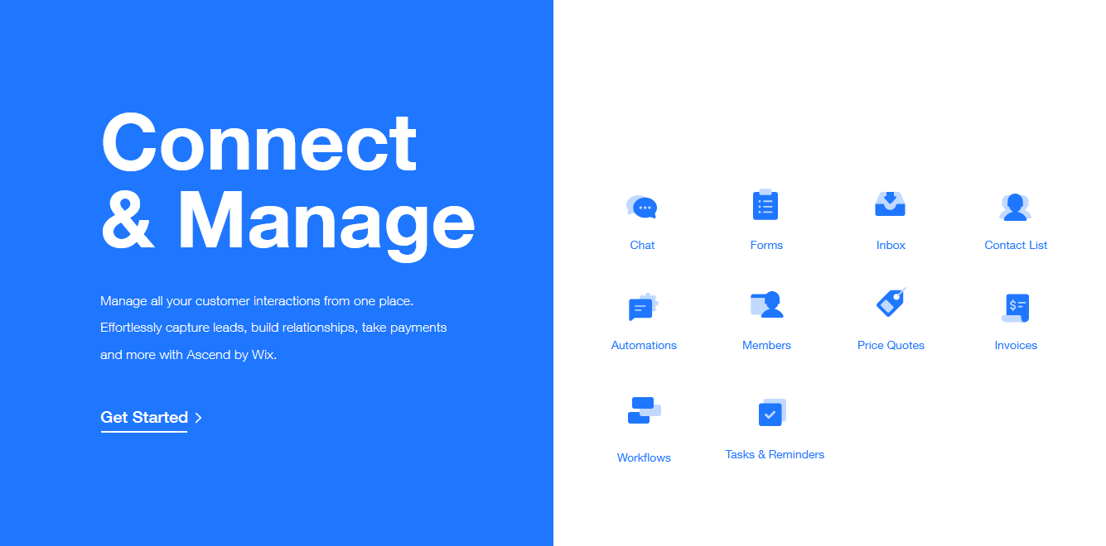

Some are Promote & Grow Ascent :

- Seo Tools
- Email Marketing
- Social Posts
- Video Maker
- Marketing Integrations
- Coupons


Let Us discuss in depth about one Ascent module: Forms

Forms

Wix form is a Wix Ascent used to collect user information from front-end to back-end, You can add many numbers of forms as required and all the form submission data stored on wix dashboard, You can check your inbox for form submission and can set multiple wix recipient email id.

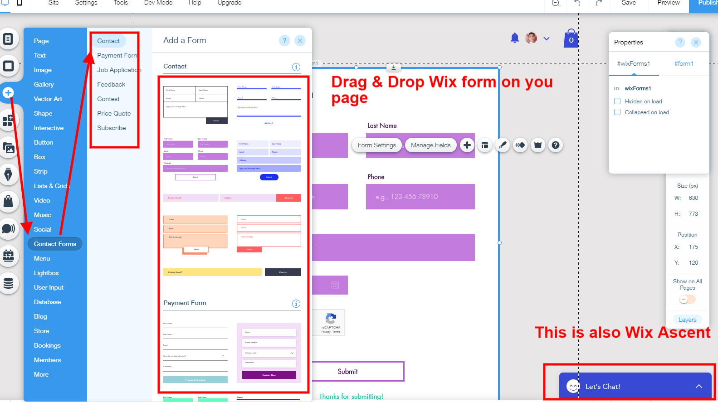

Form Setting:
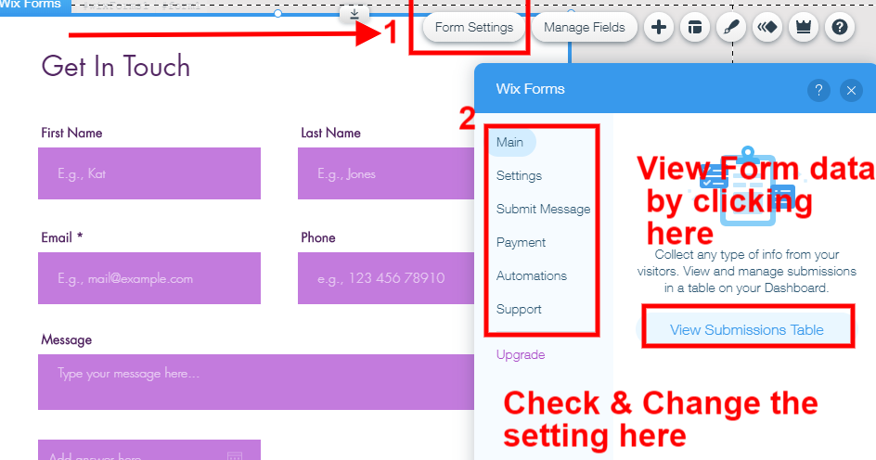
In form Setting you have to click on View Submission Table, when you click on this button then there is popup open having dashboard of all the ascents aspects their.

- Inbox
- Contact List
- Form Submission
- Automations
- Workflows
- Task & Reminders
- Site Members

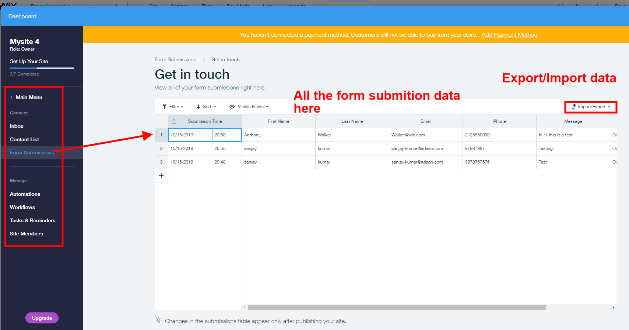

Form Automation:

Form Automation is the functionality where admin can set the automation with any wix form, if any user will submit the form then form data will go on inbox but along with that it will also automate to the automation panel which has been setted.

You can set Automation for following functions
- Send email to visitors
- Send a chat message
- Get notified by email
- Create a task
- Move card in a workflow
- Connect to Zapier
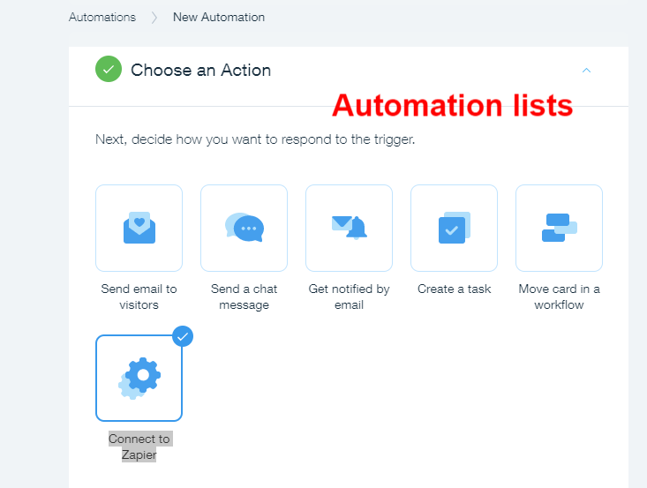

Suppose we have connected form with create a task Automation , so when any form will submit then a task will created automatically on the dashboard

Email Marketing

Email marketing is the wix Ascent part used for creating email campaign for email boosting and customer creating.

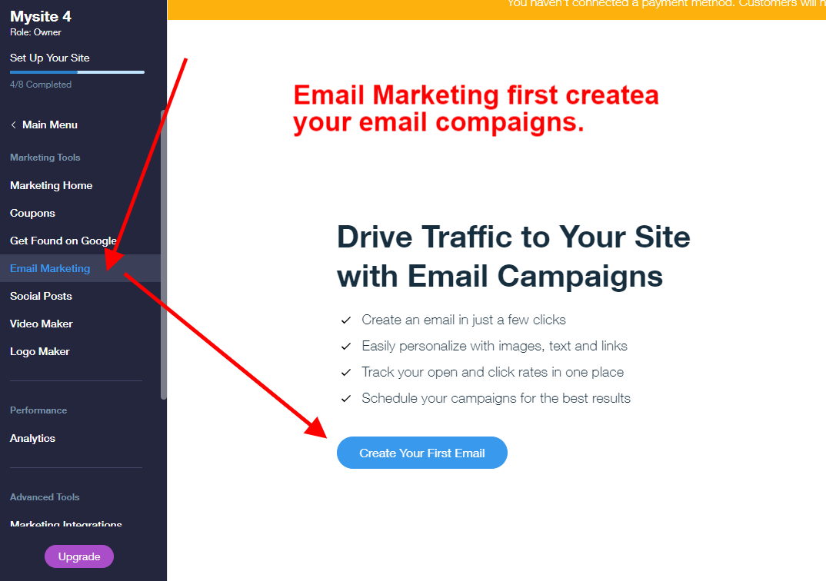

Process:
- Create you first email campaign
- Design Email Template
- Add Recipient or send to bulk email
- Publish & Send
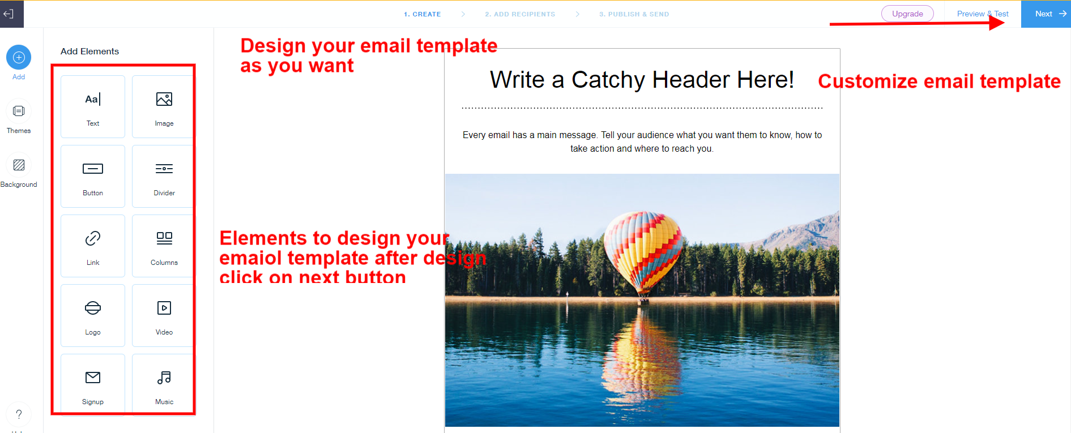

SOCIAL Posting

Into:
Social post is the Wix Ascent used for engaging social media. Posting on social medias like facebook, twitter , Instgram etc.

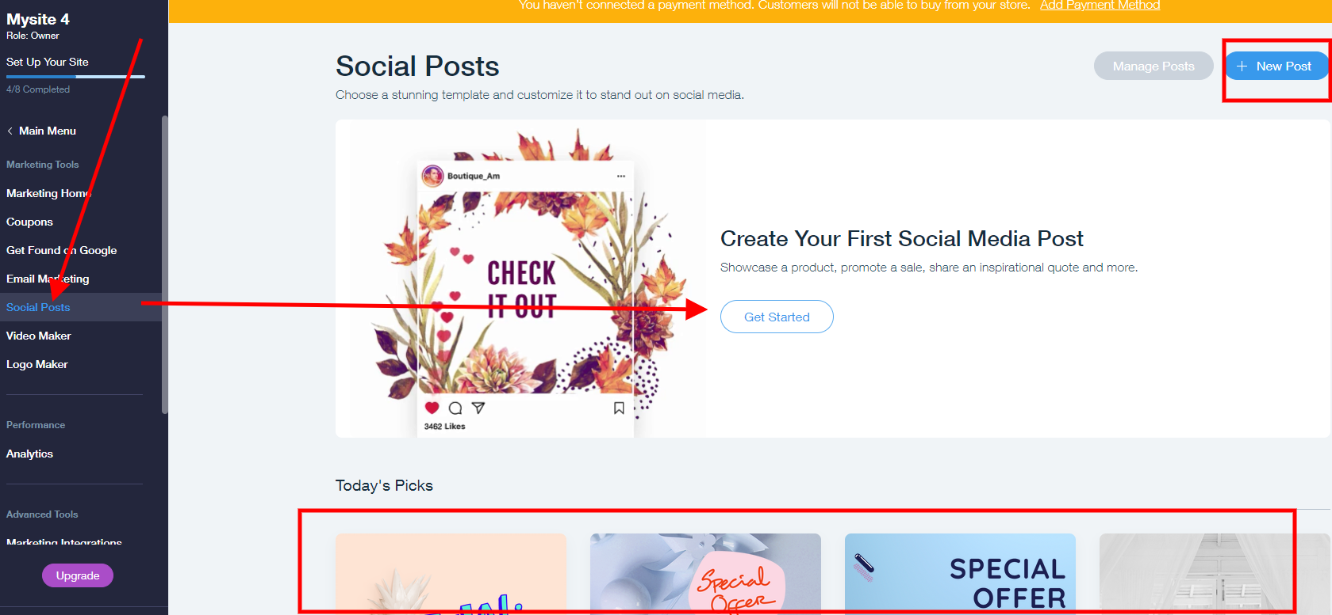

Process
- Create your first post or you can pickup wix ready posts from listed there
- Customize the post design
- Share on social media by connecting to your own social account by login
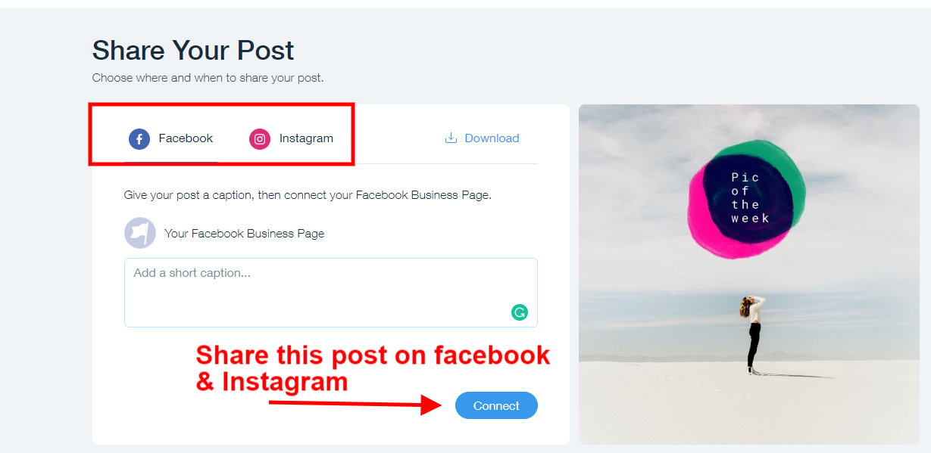

Video Maker

Easily create videos that are perfect for sharing on Facebook, Instagram, YouTube, and more. Just create your official video and can share on any platform.

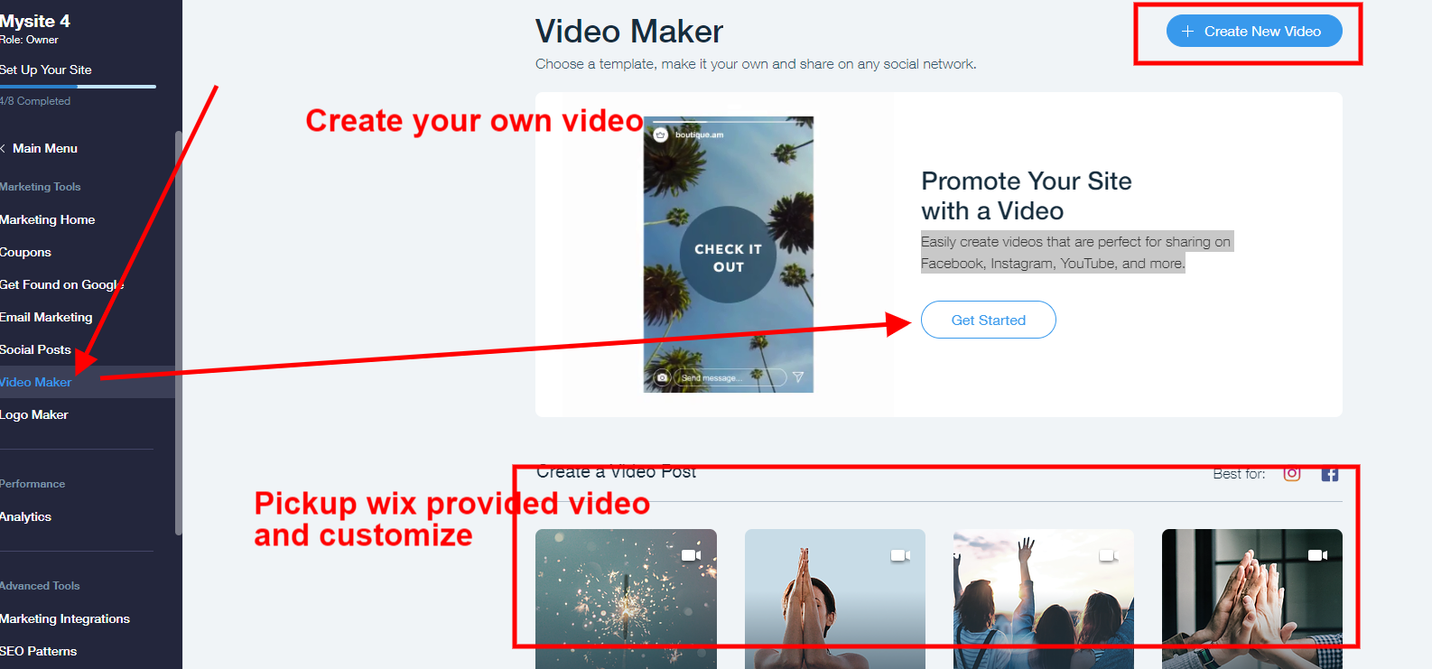

Process:
- Create your own video
- Or Pickup wix provided video
- Add content on video
- Change image to show on video
- Add business info in video
- Add music background on video
- Then create video and share on social media
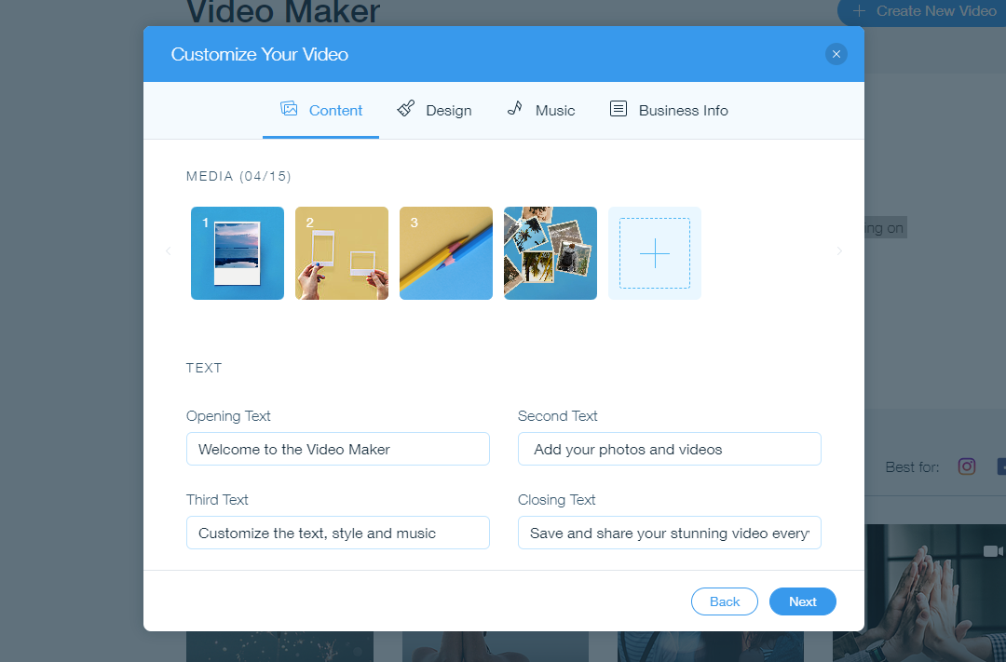

SEO Tools

Intor :
Seo Tools are the seo wiz in wix which enable the wix website to be found on search engines. To get found online with a powerful search engine.

For this we need to get a personalized SEO plan and connect to Google in a single click. Wix provide best SEO for our Websites

Using Wix Seo Wiz we can do following work
- Pick your keywords
- Follow your personalized plan
- Get your website ranked
- Instant Google indexing
- Achievement Trackers etc.

Steps for SEO Wix

Please follow the steps to complete the seo wiz

Step 1:
Go to Page Manage Page : on the list of pages click on toggle icon click on Seo ( Google )

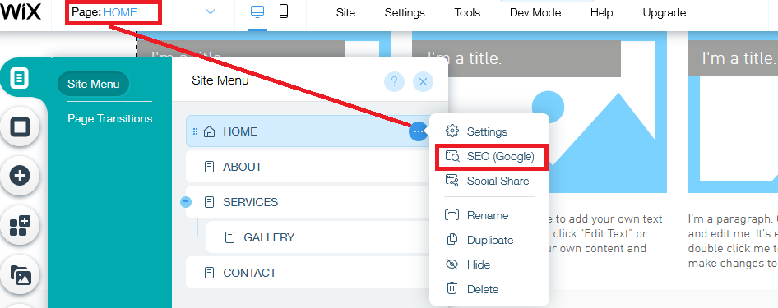

Step 2:
Enter Seo Title of the page and seo description of the page

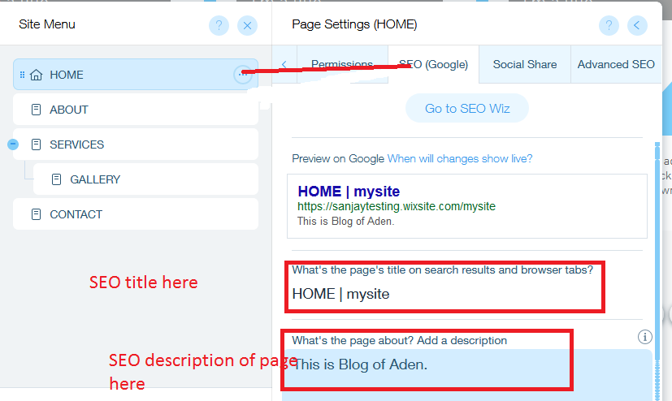

Step 3:

Click on Advanced SEO tab
Add Structured Data : A JSON-LD Code in textarea

For JSON-LD Code
- Open the link https://jsonld.com/json-ld-generator/ or you can get json ld generator link from google search
- Enter all the details on the form
- Generator will generate json code
- Copy the json-ld code
JSON-LD code is similar like:
<script type='application/ld+json'>
{
"@context": "http://www.schema.org",
"@type": "AutoRepair",
"name": "Test",
"url": "test",
"logo": "test",
"priceRange": "$",
"description": "testt",
"address": {
"@type": "PostalAddress",
"streetAddress": "New Delhi",
"addressLocality": "New Delhi",
"addressRegion": "New Delhi",
"postalCode": "New Delhi",
"addressCountry": "India"
},
"telephone": "4534543515"
}
</script>

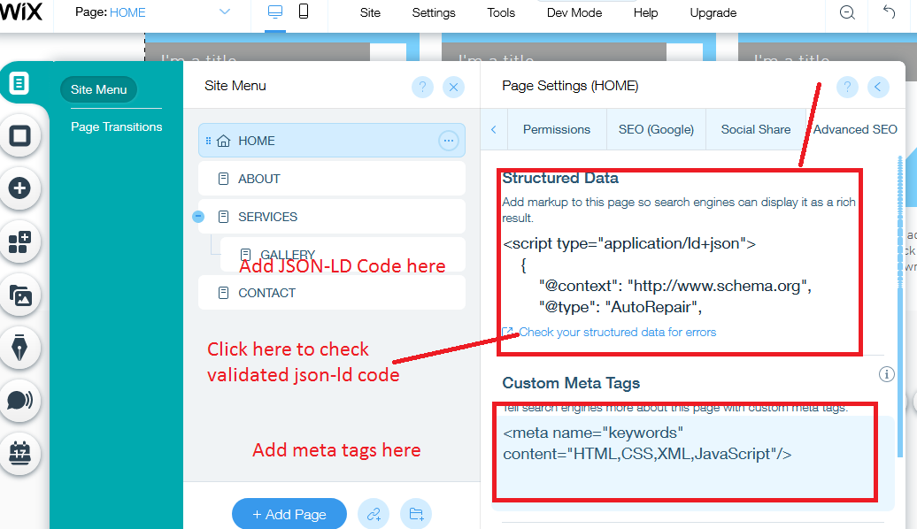

Note: Click on Check your structured data for error link to check valid JSON-LD code, if there is error ther you need to generate again json code.
JSON preview must have error free code.

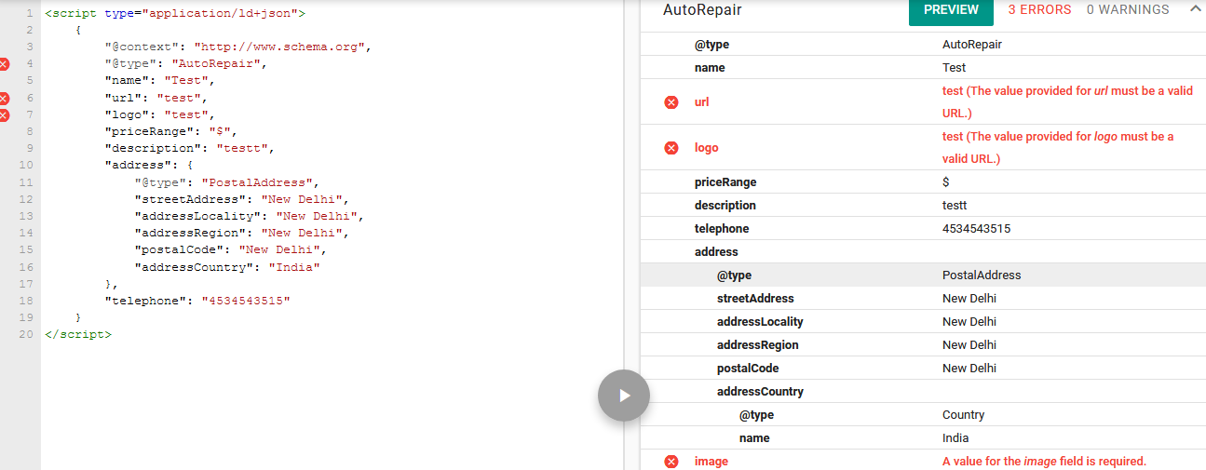

Step 4:
Go to the SEO (Google) tabs
And Click on Go to SEO Wiz button
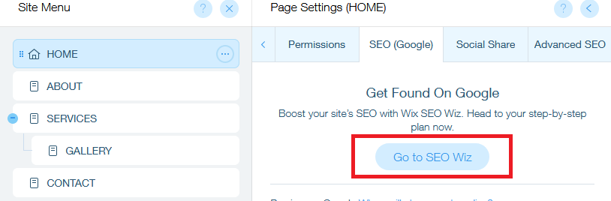

Then new page open in new tab.
This page is Wix seo setting page in admin dashboard to set all the seo points in one place.

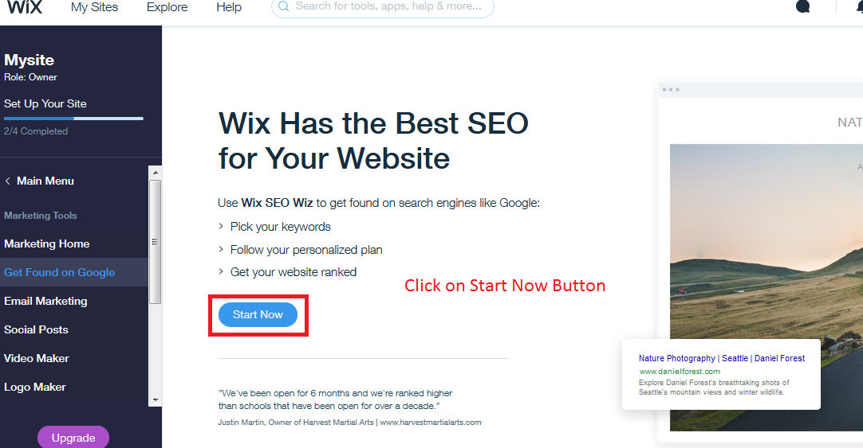

After clicking on start now
It will ask about your site name , Business Location, business description and many few things. Just enter the detail and then finally you will find the list of pointers of all the SEO points which has been checked.

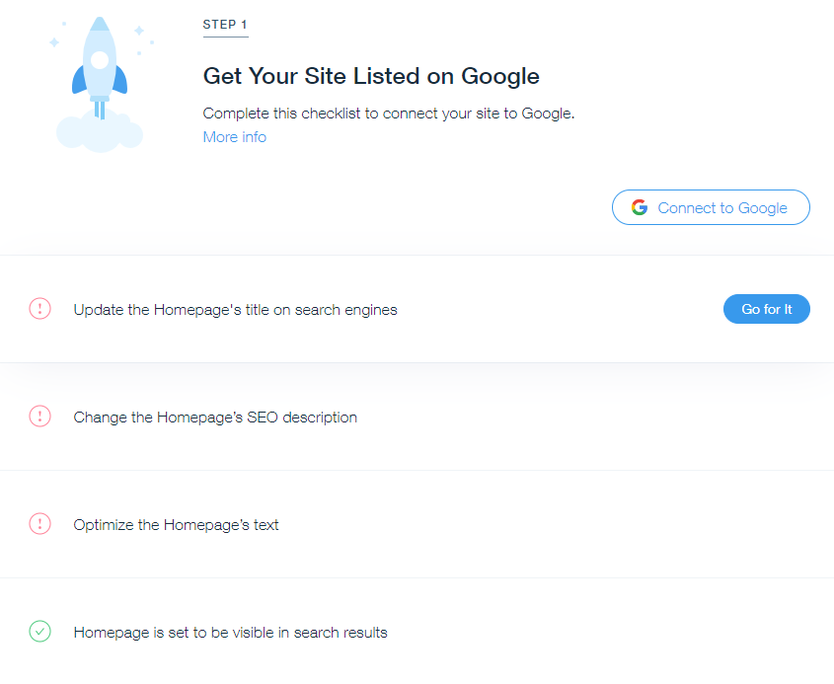

Publish Your site
Once the following point has been done:
- Pages Design
- Ascent add like form and chat
- Form setting and automation created
- Seo of all the pages
- Json-Ld code added
- Completed SEO Wiz
Then you can publish your site
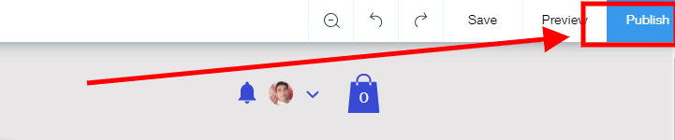

Connect With Live Domain
Upgrade your site to Premium members and then you can connect with live domain

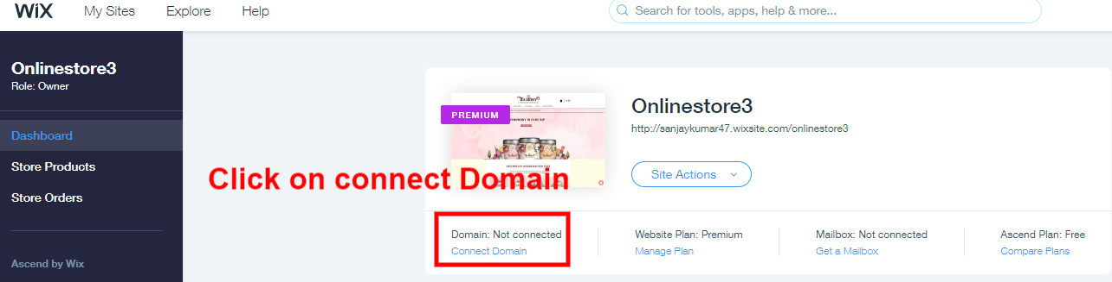

If you already have a domain then you can go with connect your domain but if you don't have domain then you can buy a domain from wix platform itself and will connect with your website.

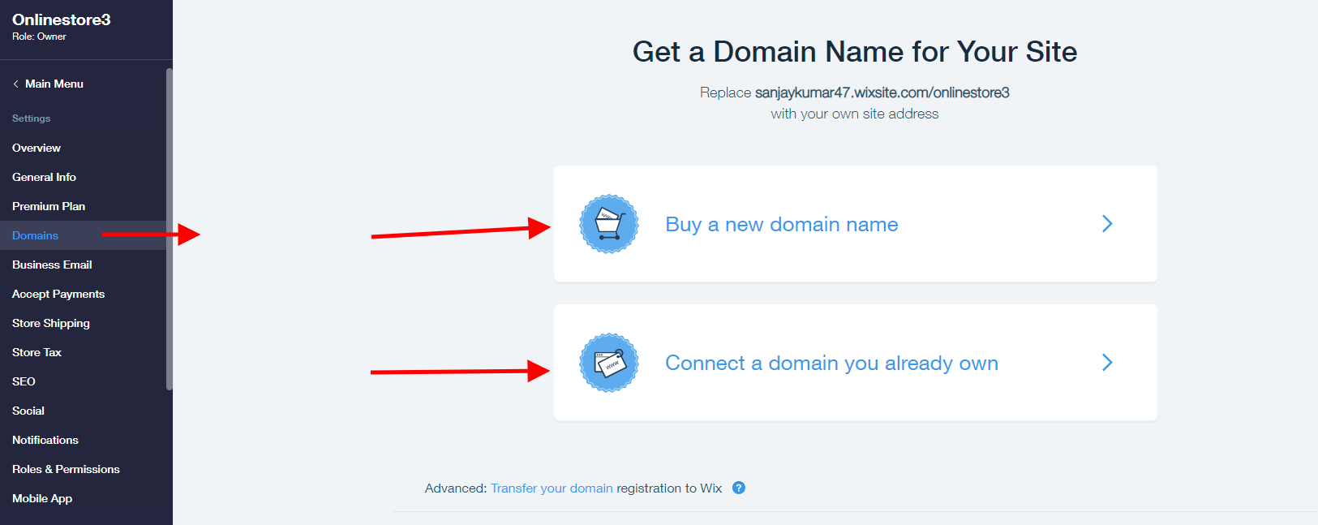

Comparison with Other Platforms
-------------------------------------------------------------

- Wix vs Wordpress vs Shopify
------------------------------------------------------------------------------
Wix is an easy to use site builder with flexible designs, ideal for portfolio-type of websites. Building a large and complex site isn’t recommendable as the navigation is quite limited.
WordPress allows you to create virtually any type of website but requires more technical knowledge.

Wix and WordPress use completely different technical approaches:
while all Wix packages include hosting and tech support, WordPress requires you to take care of this yourself. You need to find a web host and install it on your own web space. It's you who is responsible if there are any technical issues.

Wix comes with around 300 free templates. They are slick, modern, and segmented into categories (photographers, restaurants, blogs, etc…). One downside is that they’re not responsive, so you may need to re-arrange (using drag and drop) the elements to make your site look nice on phones.

With WordPress, if you know CSS and HTML, or if you don’t mind spending a few hours working out how to modify your template’s code – you can get exactly the website you want. Plus, you will find tons of responsive WordPress themes online. They usually cost between $30 & $60 (have a quick look on Themeforest), and most of them are responsive.

Wix’s dedicated online store section and make it better suited to small businesses. For instance, the shipping and tax options are quite limited. What’s great is that it also supports digital goods and that it’s one of the more affordable ecommerce tools.
WordPress website, you’ll have none of these problems. That’s provided you use a third party plugin of course, because otherwise there’s nothing out of the box.
Shopify: a dedicated ecommerce heavyweight and one of the best overall ecommerce platforms on the market
24/7 Support: Shopify offers round-the-clock support over the phone and live chat. You’re never left alone when running your store.
Shopify : Over 100 payment options. Wide range of payment options available, including PayPal, Stripe and Shopify’s own fully-integrated payments system.
Wix is cheaper as compared to Shopify for ecommerce solutions.

Summary:
Wix is a drag and drop featured website builder with their own hosting only. It is very preferable for simple blogging sites, small business and a lot of stunning design for other purposes of websites which have less functionality like portfolio, showcases, informative sites etc.

